Total distance: 102019.40278000449

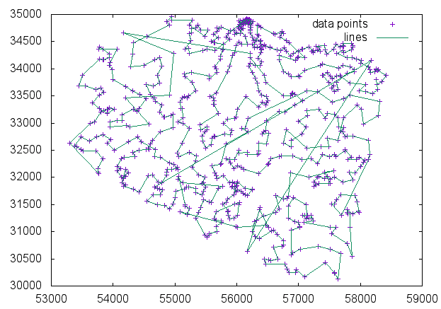

**What is your population size?**

My genetic algorithm starts with a population size of 50 greedy paths with slight mutations added to them.

**How do you select the parents to breed?**

In each generation, 50 pairs of parents are selected randomly and then mated

**How many children do you breed at a pass (is it 1, as in class, or some other scheme)?**

Two children are produced from each pair.

**How do you select the pivot point (for the gene splicing)?**

Children are bred by selecting a random pivot point and then crossing over the two parents.

**How do you decide when to mutate?**

There is a 5% chance of children undergoing mutation.

**What is your mutation?**

When a child is mutated, a subpath between two random cities in the child’s position list is reversed.

**What happens if a child is produced that is identical to an already existing population member?**

Duplicate children are not a problem because the population pool is stored in a set.

**What happens if the two parents selected have the same genes?**

In my genetic algorithm, there is no special method of dealing with two parents that have the same genes.

**Additional Info:**

After the mating process, the weakest C paths, such that C = Current Population Size – Initial Population Size, are culled from the population, leaving a population with the same size as the initial one.

[1, 3, 6, 11, 2, 7, 5, 4, 8, 10, 9, 14, 13, 12, 15, 23, 24, 26, 28, 34, 40, 39, 29, 31, 38, 55, 60, 69, 83, 95, 126, 120, 121, 124, 208, 190, 215, 212, 171, 170, 169, 162, 165, 180, 191, 195, 187, 196, 184, 192, 181, 182, 213, 209, 229, 240, 242, 257, 247, 246, 256, 289, 281, 263, 270, 262, 269, 237, 253, 245, 266, 265, 261, 252, 236, 234, 205, 220, 227, 231, 224, 239, 251, 243, 244, 284, 274, 277, 267, 268, 272, 280, 305, 301, 332, 330, 336, 340, 364, 368, 392, 390, 411, 424, 447, 451, 446, 448, 439, 438, 478, 497, 555, 570, 667, 568, 441, 427, 356, 350, 354, 349, 362, 366, 367, 382, 399, 391, 394, 404, 425, 444, 456, 466, 482, 516, 531, 540, 595, 593, 608, 594, 565, 553, 546, 545, 549, 495, 467, 468, 461, 464, 452, 440, 415, 403, 385, 398, 407, 397, 396, 393, 388, 361, 358, 302, 204, 210, 221, 249, 279, 278, 285, 293, 297, 318, 309, 319, 327, 315, 303, 282, 307, 320, 308, 288, 259, 255, 238, 232, 219, 225, 223, 218, 217, 211, 202, 173, 177, 201, 198, 136, 144, 158, 164, 172, 216, 206, 197, 193, 185, 188, 214, 222, 228, 250, 254, 258, 275, 283, 286, 287, 290, 299, 311, 333, 347, 383, 380, 377, 376, 389, 409, 420, 429, 428, 445, 471, 469, 474, 496, 528, 554, 547, 532, 524, 566, 634, 652, 692, 712, 734, 723, 724, 693, 653, 676, 675, 694, 683, 679, 668, 661, 641, 596, 603, 569, 582, 597, 583, 647, 649, 662, 726, 725, 706, 716, 722, 711, 686, 681, 654, 627, 625, 638, 620, 574, 563, 529, 510, 450, 434, 432, 423, 413, 414, 386, 355, 341, 351, 342, 334, 323, 310, 291, 298, 316, 324, 321, 329, 328, 339, 360, 369, 370, 378, 400, 435, 408, 418, 410, 416, 422, 436, 442, 458, 475, 486, 507, 530, 538, 533, 534, 541, 552, 573, 592, 599, 606, 609, 605, 628, 629, 655, 658, 697, 691, 687, 663, 659, 671, 665, 664, 650, 642, 637, 557, 560, 556, 542, 564, 548, 511, 503, 488, 489, 492, 514, 535, 537, 523, 536, 526, 517, 512, 504, 480, 462, 454, 465, 470, 479, 498, 499, 508, 493, 485, 494, 500, 490, 476, 472, 460, 455, 449, 463, 483, 473, 481, 501, 515, 520, 522, 519, 513, 509, 518, 527, 539, 543, 551, 559, 558, 572, 585, 576, 591, 614, 623, 633, 632, 618, 622, 613, 630, 602, 567, 590, 621, 617, 612, 580, 589, 575, 579, 584, 611, 601, 600, 578, 571, 562, 581, 577, 607, 586, 588, 604, 610, 616, 624, 619, 615, 631, 643, 640, 646, 645, 644, 651, 666, 672, 678, 685, 688, 695, 696, 715, 721, 720, 708, 709, 705, 704, 701, 702, 710, 713, 718, 719, 731, 730, 728, 729, 733, 732, 727, 717, 714, 707, 703, 700, 698, 699, 690, 682, 674, 660, 657, 669, 677, 673, 689, 684, 680, 670, 656, 648, 639, 635, 636, 626, 598, 587, 561, 550, 525, 521, 506, 484, 491, 505, 502, 487, 477, 457, 437, 431, 433, 430, 417, 405, 406, 373, 363, 359, 344, 304, 273, 260, 276, 264, 241, 226, 203, 189, 166, 175, 155, 139, 130, 135, 149, 154, 153, 146, 138, 122, 106, 94, 101, 102, 116, 128, 129, 141, 145, 148, 152, 544, 20, 98, 92, 43, 51, 42, 49, 87, 78, 96, 99, 103, 194, 183, 174, 159, 150, 111, 114, 117, 97, 82, 64, 32, 30, 33, 35, 37, 48, 52, 57, 59, 61, 88, 108, 113, 104, 71, 65, 62, 70, 89, 90, 107, 112, 119, 131, 179, 151, 147, 143, 125, 132, 134, 140, 142, 137, 156, 160, 157, 161, 163, 168, 167, 178, 176, 200, 186, 199, 207, 230, 233, 235, 300, 335, 345, 346, 371, 459, 453, 419, 426, 443, 421, 379, 357, 402, 412, 375, 313, 317, 296, 295, 292, 343, 306, 294, 312, 331, 352, 365, 381, 395, 401, 372, 387, 384, 374, 353, 348, 338, 337, 322, 325, 326, 314, 271, 248, 77, 109, 110, 118, 133, 127, 115, 86, 91, 81, 93, 84, 85, 79, 80, 47, 16, 27, 36, 46, 45, 54, 58, 76, 68, 67, 63, 72, 73, 75, 74, 105, 123, 100, 66, 56, 53, 50, 44, 41, 17, 19, 21, 25, 22, 18]